**A Hybrid Model for Accurate Plant Disease Classification and Segmentation**

**ABSTRACT**

**Plants are essential for life on earth, providing oxygen, food, medicine, and many other resources. They also play an important role in maintaining the balance of the ecosystem by absorbing carbon dioxide and releasing oxygen through the process of photosynthesis. Plant diseases are caused by pathogens such as bacteria, viruses, fungi, and nematodes, resulting in damage to the plant's growth and yield. Early detection and management of plant diseases are crucial for maintaining crop productivity and preventing the spread of the disease. In this research, a hybrid model for plant disease classification and segmentation is presented. The dataset used for this study is the plantVillage dataset, which has 12 classes of plant diseases. The dataset was annotated manually using the VGG annotator tool, and generated using a Generative Adversarial Network (GAN). The aim of this research is to develop a model that can accurately classify and segment plant diseases. For classification, four transfer learning models were used, and the average accuracy obtained was 97.78% from ResNet9. The hybrid model for classification achieved an accuracy of 98.96%, which demonstrates the effectiveness of using a hybrid approach for classification in this specific task. For segmentation, both instance and semantic segmentation were used, with VGGSegnet, Mask-RCNN and Unet respectively. Instance segmentation was used to identify different instances of the plant in an image, while semantic segmentation was used to classify each pixel of the image into one of the 12 classes. A hybrid algorithm for segmentation was also built, which outperformed other algorithms and achieved 99.25% accuracy for classification and segmentation. This high accuracy in the hybrid algorithm for segmentation demonstrates its effectiveness in localizing the disease areas in the plants. The use of GAN for generating the dataset, and the combination of transfer learning models for classification and instance and semantic segmentation for segmentation, results in a robust and accurate model. The hybrid approach not only improves the classification and segmentation accuracy, but also allows for a better understanding of the disease by localizing the affected area in the plant. This can be a valuable tool for plant disease detection and management in agriculture. Additionally, this research could serve as a model for other image classification and segmentation tasks in different domains. In this research, we built a hybrid model that can serve as a valuable tool for plant disease detection and management in agriculture, as well as a model for other image classification and segmentation tasks in different domains.**

**Keyword Indexing : *plant disease; classification; segmentation; hybrid model; GAN.***

1. **INTRODUCTION**

Precision agriculture is an approach that uses advanced technology and data analysis to improve crop yields and reduce the spread of diseases. One of the key components of precision agriculture is the ability to accurately classify and segment plant diseases. This can help farmers identify and isolate infected areas of their crops, leading to more efficient use of resources and improved crop yields. In this research, we propose a hybrid model for accurate plant disease classification and segmentation.

The PlantVillage dataset, which contains 12 classes of plant diseases, was used as the dataset for this research. The dataset contains a wide range of plant diseases and provides a comprehensive dataset to train and test the model. However, the images in the dataset may contain noise, which can negatively impact the performance of the model. In order to improve the quality of the images, we applied denoising using a generative adversarial network (GAN) and data augmentation techniques. GANs are neural networks capable of generating new data similar to the training data, in this case, the GAN is used to remove noise from the images, making them clearer and more useful for analysis.

Data augmentation techniques, such as flipping, rotating, and zooming, were used to increase the number of images available for training and improve the robustness of the model. Data augmentation helps to prevent overfitting by creating new training data from the existing data by applying various transformations. This helps the model to generalize better and improve its performance on unseen data.

For classification, we evaluated three different convolutional neural network (CNN) architectures: EfficientNetB1, VGG16, and ResNet9. These architectures are some of the most commonly used CNNs and have been proven to be effective in image classification tasks. EfficientNetB1 achieved the best accuracy of 97.38%, but we observed that it sometimes predicted wrong classes. To overcome this limitation, we built a hybrid model using all three architectures, which resulted in a higher accuracy of 98.78%. The idea behind using a hybrid model is to combine the strengths of different models and overcome their limitations. By combining the predictions of multiple models, the hybrid model can make more accurate predictions.

For segmentation, we evaluated two different approaches: instance and semantic segmentation. Instance segmentation is the task of detecting and segmenting individual objects within an image, while semantic segmentation is the task of classifying each pixel in an image. We used Mask-RCNN, VGGSegnet for localization of the disease area and Unet for segmentation. All are performed satisfactory results, but our main goal was to create a hybrid algorithm in the segmentation part as well. We achieved this by combining the strengths of both approaches, resulting in more accurate segmentation of the plant diseases.

The hybrid model can help farmers to quickly and accurately identify infected areas of their crops, leading to more efficient use of resources and improved crop yields. This can also help to prevent the spread of diseases by isolating infected areas and applying appropriate treatments. Furthermore, the use of GAN for denoising and data augmentation further enhanced the quality of the images and the proposed hybrid model for segmentation can effectively localize and segment the disease areas in an image.

In conclusion, the proposed hybrid model for plant disease classification and segmentation in this research achieved a high level of accuracy and improved the performance of the single architectures. The use of GAN for denoising and data augmentation further enhanced the quality of the images. The proposed hybrid model for segmentation can effectively localize and segment the disease areas in an image. This research can help farmers to quickly and accurately identify infected areas of their crops, leading to more efficient use of resources and improved crop yields. Additionally, this research can also help to prevent the spread of diseases by isolating infected areas and applying appropriate treatments. In future work, we plan to further improve the performance of the model by incorporating additional data, such as weather data and soil data, and exploring other advanced techniques such as transfer learning. Additionally, we plan to test the model on a larger dataset with more classes of plant diseases to evaluate its generalizability. We believe that the proposed hybrid model can serve as a useful tool for precision agriculture and contribute to the sustainable development of the agricultural industry.

1. **RELATED WORK**

In recent years, rice crops have been recognized as a vital source of energy and resources for the agricultural industry. However, the increasing prevalence of rice plant diseases has led to significant agricultural, economic, and communal losses. In order to combat these diseases, researchers have been exploring image processing techniques for the diagnosis and identification of plant diseases. For completed our research we reviewed other researcher’s work to gain about the limitation and progress of this plant disease detection. Over the past decade, there have been a number of studies conducted on the development of disease detection, identification, and quantification methods for a variety of crops. This literature review focuses on research papers published between 2020 to 2023 and examines the state of the art in this field. The studies reviewed are compared based on their use of image segmentation, feature extraction, feature selection, and classification techniques.

One of them Anjnaa , Meenakshi, Pradeep [1] worked an automated system to detect and classified the plant disease in 2020. The main goal of the research discussed in this paper is to analyze plant diseases early in order to take effective control actions. The proposed system was tested on 62 images of healthy and diseased capsicum plants and their leaves, with an accuracy of 100% using SVM. The proposed algorithm in the paper automatically identifies capsicum diseases by extracting the infected area of the plant using k-means clustering and then analyzing the texture, or GLCM features, of the infected area. This information is then used to classify the type of disease (bacterial or fungal) using various classifiers such as Tree, Linear Discriminant, KNN, and SVM. The research found that out of these classifiers, KNN and SVM gave the best results for the given application. Overall, the research in this paper highlights the importance of early analysis and classification of plant diseases in order to take effective control actions and improve crop production.

Prabira, Nalini, Amiya [2] highlights the current achievements in the diagnosis of rice plant diseases, including the use of image processing techniques for disease identification and quantification. However, it also notes the limitations of these methods, such as the need for high-quality images and the difficulty of accurately classifying certain diseases. They suggests that image processing techniques have the potential to greatly improve the diagnosis and identification of rice plant diseases. However, further research is needed to address the limitations and improve the accuracy of these methods.

Parul, Yash, Wiqas [3] investigates a potential solution to this problem by using segmented image data to train convolutional neural network (CNN) models. The researchers compared the performance of a CNN model trained using full images (F-CNN) to one trained using segmented images (S-CNN). The results showed that the S-CNN model had a significantly higher accuracy of 98.6% when tested on previously unseen data, even when considering 10 different disease classes. Their study also used tomato plants and target spot disease as an example to demonstrate that the S-CNN model had a significant improvement in self-classification confidence compared to the F-CNN model. Overall, this research brings the applicability of automated disease detection methods closer to non-experts, and could potentially lead to more timely and effective disease management in crops.

Azim, Khairul, Farah [4] they worked on plant leaves disease segmentation in 2021 and in their paper they proposed a model for detecting three common rice leaf diseases: bacterial leaf blight, brown spot, and leaf smut. The model uses a saturation threshold to remove the background of images, and a hue threshold to segment the disease-affected areas. Distinctive features are extracted from the affected areas using color, shape, and texture domain, which can robustly describe the local and global statistics of the images. The authors of the paper tested several classification algorithms and found that extreme gradient boosting decision tree ensemble was the most effective method for the proposed model. The model achieved an accuracy of 86.58% on the rice leaf diseases dataset from UCI, which is higher than previous works on the same dataset. Additionally, the class-wise accuracy of the model was consistent among the classes.

In this paper, the authors Khalil, Rehan [5] they also proposed a automated project for leaf segmentation to detect the classification of disease. They propose a deep convolutional neural network based on semantic segmentation (SS) for the classification of ten different diseases affecting a specific plant leaf. The model successfully highlights the foreground (leaf) and background (non-leaf) regions through SS, identifying regions as healthy and diseased parts. The semantic label provided by the proposed method for each pixel also allows for the estimation of the area of a specific leaf affected by a disease.The authors use tomato plant leaves as a test case for their work and test the proposed CNN-based model on the publicly available database, PlantVillage. Additionally, the authors also collected a dataset of twenty thousand images and tested the framework on it. The proposed model obtained an average accuracy of 97.6%, which shows a substantial improvement in performance on the same dataset compared to previous results.

Raj, Anuradha, Amit [6] their study showed that in the category of machine learning-based approaches, 70% of studies utilized real-field plant leaf images, while 30% utilized laboratory-conditioned plant leaf images for disease classification. In the case of deep learning-based approaches, 55% of studies employed laboratory-conditioned images from the PlantVillage dataset, 25% utilized real-field images, and 20% utilized open image datasets. The average accuracy attained with deep learning-based approaches was 98.8%, which was higher than that of machine learning-based approaches at 92.2%.

Pooja, Shubhada [7] they focuses on the various approaches that have been developed for the detection of diseases in plants using their images. Image processing is a method that has been successfully used for the recognition of plant maladies. The use of machine learning algorithms, such as neural networks and decision trees, has also been explored to improve the accuracy of disease detection.

Jinzhu , Lijuan and Huanyu [8] the authors reviewed the latest CNN networks relevant to plant leaf disease classification. They summarized the DL principles involved in plant disease classification and discussed the main problems and corresponding solutions of CNNs used for plant disease classification. Additionally, they discussed the future direction of development in plant disease classification. They collected some public plant datasets from the two websites Kaggle [[9](https://www.kaggle.com/datasets)] and BIFROST [[10](https://thebifrost.io/)]. The proposed model achieved an accuracy of 91.83% on the public dataset PlantVillage and 92.00% on their own dataset.

Kamal, Yin, Li [11] the authors propose a system that combines edge and morphological-based segmentation, background subtraction, and a convolutional neural network (CNN) to improve accuracy on image sets with clean and cluttered backgrounds. Experimental results on two, four, and eight class datasets show that the proposed method achieves 98.7%, 96.7%, and 93.57% accuracy by fine-tuned DenseNet121, InceptionV3, and DenseNet121 models, respectively, on a clean dataset. For two class datasets, the accuracy obtained was about 12% higher for a dataset with images taken in a homogeneous background compared to that of a dataset with testing images with a cluttered background.

Shoaib, Muhammad; Hussain, Tariq; Shah, Babar [12] developed a deep learning based automatic system to segmented and classification of leaf disease in 2022. In this work, the authors propose a solution for detecting tomato plant diseases using a deep learning-based system that utilizes plant leaf images. They used an architecture for deep learning based on a recently developed convolutional neural network that is trained over 18,161 segmented and non-segmented tomato leaf images. For the detection and segmentation of disease-affected regions, the authors used two state-of-the-art semantic segmentation models, U-Net and Modified U-Net. The Modified U-net segmentation model outperforms the simple U-net segmentation model by 98.66 percent, 98.5 IoU score, and 98.73 percent on the dice. InceptionNet1 achieves 99.95% accuracy for binary classification problems and 99.12% for classifying six segmented class images. InceptionNet outperformed the Modified U-net model to achieve higher accuracy.

Jaafar , Yiannis, Sri, Pamela Roberts [13] In this study, 35 spectral vegetation indices (VIs) were calculated to select an optimum set of indices for disease detection and identification. The study focused on two specific diseases: brown spot (BS) and target spot (TS). They found that the most significant VIs that could distinguish between healthy leaves and diseased leaves were the photochemical reflectance index (PRI) for both diseases. MLP classification method had an accuracy of 99% for both BS and TS under field (UAV-based) and laboratory conditions.

TAN, TRAN, TRUONG [14] the authors aim to detect early disease on plant leaves using an artificial neural network (ANN) approach. They compare the results obtained using their methods with another approach using popular CNN models (AlexNet, EfficientNetB1, ResNet-50) enhanced with transfer learning. The results show that the ANN's performance was better than that of the CNNs using a simpler network structure (89.41% vs 78.64%, 79.92%, and 84.88%, respectively).

Paul, Armandine [15] also tried to segmentented the leaf images to detect the plant disease. The authors propose a method to evaluate segmentation algorithms (k-means clustering, canny edge, and k-nearest neighbor) on the diagnostic of diseases of three of the most cultivated plants (corn, potato, tomato) in the region of study. They study and compare performance values using the ROC-AUC of disease

classification using the Support Vector Machine (SVM) algorithm. The obtained results show that the canny edge algorithm produces poor performance on the family of solanaceae plants, including potatoes. The k-nearest neighbor algorithm produces poor performance due to the difficulty of choosing the k-value. Finally, the k-means algorithm makes it possible to obtain good prediction rates on all the chosen plants.

Eisha, Neeraj, Kamal [16] worked on a neural network based automatic detection for Maize plant disease. In this study, an efficient automated diagnosis method for maize plants was developed. The proposed methodology consists of four stages: preprocessing, feature extraction, classification, and segmentation. The images were first converted into RGB format and the images present in the noises were removed. The R band was then given to the feature extraction stage, and the selected attributes were fed to the classifier to classify the image as normal or abnormal. For classification, an optimized probabilistic neural network (OPNN) was utilized. The PNN classifier was improved by using the artificial jelly optimization (AJO) algorithm. The study aimed to address the problem of efficiently diagnosing maize plants.

LILI, SHUJUAN, WANG [17] Their paper provides an overview of current trends and challenges in the detection of plant leaf diseases using deep learning and advanced imaging techniques. The authors aim to provide a valuable resource for researchers studying the detection of plant diseases and insect pests. The paper also highlights some of the current challenges and problems that need to be addressed in the field.

Yasamin, Javad, Esmaeil [18], The study proposes a lightweight deep learning approach using the Vision Transformer (ViT) for real-time automated plant disease classification. In addition to the ViT, the study also implements classical convolutional neural network (CNN) methods and the combination of CNN and ViT. The proposed approach of using a lightweight deep learning approach, specifically the Vision Transformer, for real-time automated plant disease classification, could be a practical solution for farmers to detect and prevent plant disease in a timely manner.

A. , N. Bharathiraja, D. Shiny [19] their study presents a novel framework for plant leaf disease identification, consisting of four steps: preprocessing, segmentation, feature extraction, and classification. The proposed model uses preprocessing techniques to remove unwanted noise and overfitting, as well as to enhance the image contrast level. The Fuzzy C-Means (FCM) based Chameleon Swarm Algorithm (CSA) named as (FCM-CSA) is used for plant leaf diseased part segmentation. The feature extraction is performed using a fast GLCM feature extraction model, and the Progressive Neural Architecture Search (PNAS) is used for plant leaf disease identification. Different measures such as precision, recall, sensitivity, specificity, and accuracy results were used to validate the performance of the proposed model. Overall, the proposed model shows promising results for plant leaf disease identification.

Ravindra, Dr. Nandita [20] worked to summarize the leaf based segmentation to detect plant disease. This research focuses on the use of machine learning and artificial intelligence-based approaches, such as Q-learning and re-enforcement learning, to detect and classify leaf diseases in plants. The authors recognize that traditional interventions may not be equipped to handle larger and more diverse sets of data. The goal is to find the best combination of algorithms to develop a highly accurate classification system for leaf diseases.

Xian, Ruzelita [21] they proposed a machine learning classifier for plant disease detection. This research aims to classify plant diseases by assessing the images of leaves using Extreme Learning Machine (ELM), a Machine Learning classification algorithm with a single layer feed-forward neural network. The proposed method uses image features as input, where the image is pre-processed using the HSV colour space and features are extracted using Haralick textures. The features are then fitted in the ELM classifier for model training and testing. The dataset used in this research comprises of tomato plant leaves, which is a subset of the Plant-Village dataset. The results of this research show that the ELM algorithm has a better accuracy of 84.94% when compared to other models such as Support Vector Machine and Decision Tree. This suggests that ELM could be a useful tool for classifying plant diseases by assessing images of leaves.

Comparative Analysis of Reviewed Paper : Discussion of Related Work

|  |  |  |  |
| --- | --- | --- | --- |
|  |  |  |  |
|  |  |  |  |
|  |  |  |  |
|  |  |  |  |
|  |  |  |  |
|  |  |  |  |
|  |  |  |  |
|  |  |  |  |
|  |  |  |  |
|  |  |  |  |

1. **RESEARCH METHODOLOGY**

For completed our work we followed a research methodology for our plant disease detection:

1. **Data collection**: The PlantVillage dataset will be used for this project, which contains images of plant leaves affected by different diseases and pests. The dataset will be downloaded from the Kaggle[22] website.
2. **Data pre-processing**: The images will be pre-processed to remove any noise and improve the overall quality of the images. This will include color space conversion, image enhancement, and image cropping.
3. **Image segmentation**: The leaves in the images will be segmented using a suitable segmentation algorithm. This will involve separating the leaf from the background, and isolating the leaf from other parts of the image.
4. **Feature extraction**: After the segmentation step, features will be extracted from the segmented leaf images. These features will include color, texture, and shape features.
5. **Model training and testing**: A machine learning model will be trained using the extracted features. The model will be trained using a suitable algorithm and fine-tuned using hyperparameter tuning. The model will then be tested using a test dataset.
6. **Model evaluation**: The performance of the model will be evaluated using metrics such as accuracy, precision, recall, and F1-score. The model will be compared with other existing models to determine its effectiveness.
7. **Deployment**: The model will be deployed in a web or mobile application, which can be used by farmers and researchers to detect diseases in plants.
8. **Conclusion and future work**: The results of the project will be analyzed, and conclusions will be drawn. Future work will include improving the model's performance by using more advanced techniques and expanding the dataset to include more plant species.

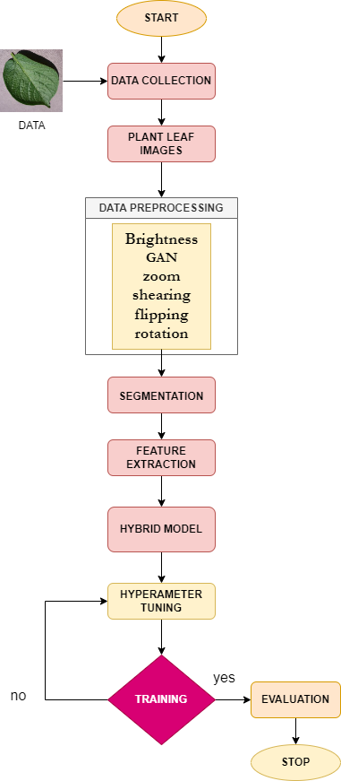

Fig.1 Working methodology of our system

**IV. DATASET DESCRIPTION**

For completed the project we use the PlantVillage Dataset. The dataset is available on Kaggle [22], and it is one of the most popular datasets for plant disease classification tasks. The dataset contains 15 classes of plant leaves, which are labeled according to the type of disease that affects the plant. The images in the dataset are captured using a variety of cameras and under different lighting conditions, making it a challenging dataset for machine learning tasks. The PlantVillage dataset is a valuable resource for researchers and developers working on image classification, plant disease detection, and other related fields, as it provides a large and diverse set of images of plant leaves. Our selected dataset attributes are Tomato___Target_Spot(259), Tomato___healthy(190),Potato___Late_blight(197),Tomato___Late_blight(222),Tomato___Early_blight(233),Potato___healthy(167),Cherry_(including_sour)___healthy(146),Corn_(maize)___Common_rust_(188),Grape___healthy(195),Apple___Apple_scab(308),Potato___Early_blight(198),Blueberry___healthy(335),Apple___Black_rot(197),Corn_(maize)___healthy(306),Grape___Esca_(Black_Measles)(171). For our segmentation part we trained 80% of total data, 10% for testing and 10% for validation.

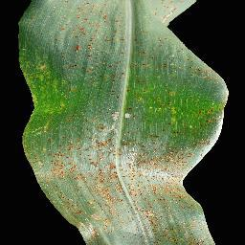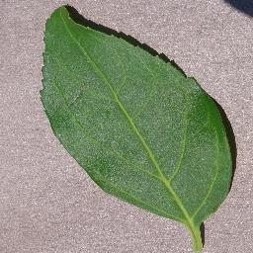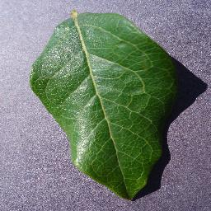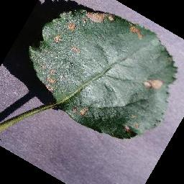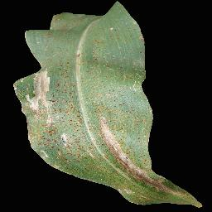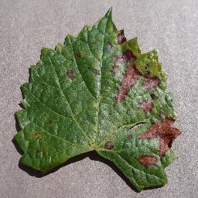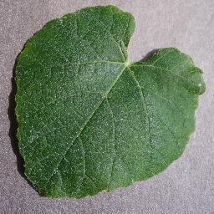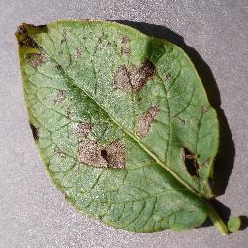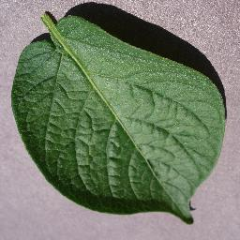

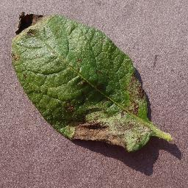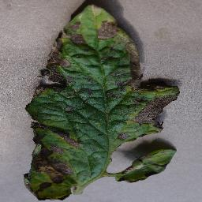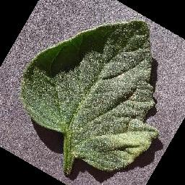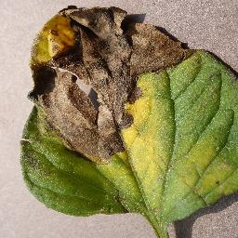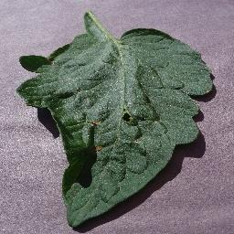

Fig.2 Sample of the 15 differents plants

Here figure no.2 shows the 15 sample of our total dataset.

| **Plant Name** | **Training Sample** | **Testing Sample** | **Validation Sample** |
| --- | --- | --- | --- |
| Tomato___Target_Spot | 207(80%) | 26(10%) | 26(10%) |
| Tomato___healthy | 152(80%) | 19(10%) | 19(10%) |
| Potato___Late_blight | 158(80%) | 19(10%) | 19(10%) |
| Tomato___Late_blight | 178(80%) | 22(10%) | 22(10%) |
| Tomato___Early_blight | 188(80%) | 33(10%) | 33(10%) |
| Potato___healthy | 135(80%) | 16(10%) | 16(10%) |
| Cherry_(including_sour)___healthy | 118(80%) | 14(10%) | 14(10%) |
| Corn_(maize)___Common_rust_ | 152(80%) | 18(10%) | 18(10%) |
| Grape___healthy | 157(80%) | 19(10%) | 19(10%) |
| Apple___Apple_scab | 248(80%) | 30(10%) | 30(10%) |
| Potato___Early_blight | 157(80%) | 19(10%) | 19(10%) |
| Blueberry___healthy | 269(80%) | 33(10%) | 33(10%) |
| Apple___Black_rot | 159(80%) | 19(10%) | 19(10%) |
| Corn_(maize)___healthy | 246(80%) | 30(10%) | 30(10%) |
| Grape___Esca_(Black_Measles) | 137(80%) | 17(10%) | 17(10%) |
| Total = 15 | 2661 | 334 | 334 |

Table No.1 Training, Testing and Validation Sample of Dataset

**V. DATASET PREPROCESSING**

To completed our project we use several method for data preprocessing. Basically we select the plantVillage dataset for this.

1. **Generative Adversarial Network (GAN)**

In this project, a Generative Adversarial Network (GAN) can be used to denoise the images of plant diseases images. The GAN consists of two main components: the generator and the discriminator.

The generator's job is to generate new, "fake" images that are similar to the original images, but with less noise. The discriminator's job is to determine whether an image is real or fake. During training, the generator is fed noisy images and learns to produce cleaner versions of these images. The discriminator is then presented with both real images and the generated, denoised images. It learns to differentiate between the real and fake images. The generator and discriminator are trained simultaneously in a process called adversarial training. The generator tries to produce images that are indistinguishable from real images, while the discriminator tries to correctly identify whether an image is real or fake. As the training progresses, the generator becomes better at producing denoised images and the discriminator becomes better at identifying real images. Once the GAN is trained, it can be used to denoise new images by passing them through the generator. The resulting images should be less noisy and more suitable for classification and segmentation tasks. Additionally, data augmentation techniques such as random rotation, flipping, and zooming can also be used to further improve the performance of the GAN. Figure No. shows us the sample after using GAN.

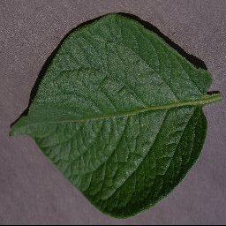 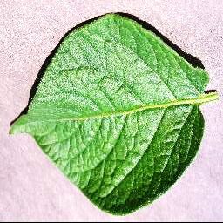

Before After

1. **Data Augmentation**

Data augmentation is a technique used to artificially increase the size of a dataset by applying random transformations to the existing images. This can help to reduce overfitting and improve the generalization of the model.In this project, data augmentation can be applied to the training images before they are fed into the GAN. This can be done using the Keras ImageDataGenerator class, which allows for a variety of different augmentations to be applied to the images.

For example, the images can be randomly rotated, flipped horizontally or vertically, and zoomed in or out. These augmentations can help to expose the model to a wider range of variations in the images, making it more robust to different types of noise and variations in the images.By applying data augmentation to the images before they are fed into the GAN, the generator can learn to denoise the images while also being more robust to different types of noise and variations. This can help to improve the performance of the GAN and ultimately the performance of the final classification and segmentation model.

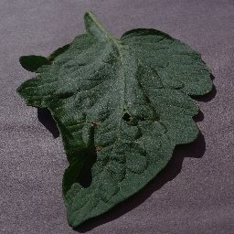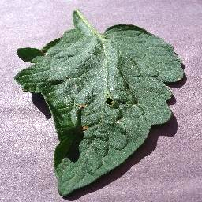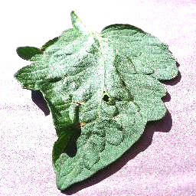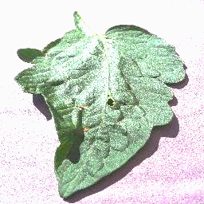

Fig. Data Augmentation

1. **Pipeline Preparation**

In this project, the images of plant diseases are preprocessed and segmented before being used for training and evaluation. The preprocessing steps include resizing the images to a standard size of 256x256 pixels, and performing data augmentation techniques such as rotation to artificially increase the size of the dataset. The segmentation process involves dividing the images into smaller regions, which are then used as input to the model. During training, the preprocessed and segmented images are compiled into batches of 64, resulting in a final input shape of 64x256x256x3 (64 images with a resolution of 256x256 pixels and 3 color channels). The images are then categorized using one-hot encoding, with each training batch paired with a 64x10 matrix representing the targets for the current batch. This allows the model to learn from the images and make predictions on unseen data.

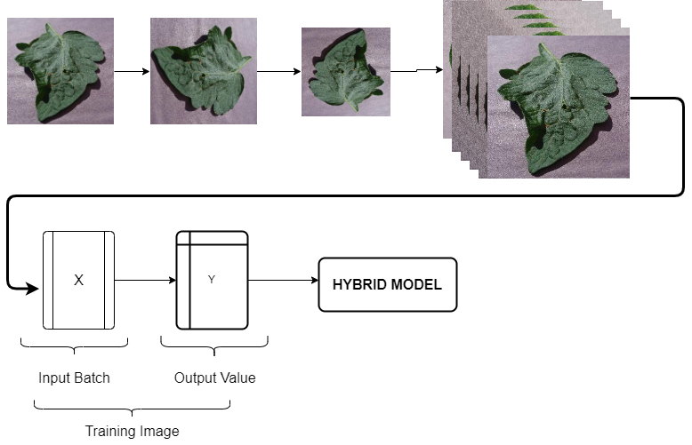

Fig. Pipeline preparation for evaluation the hybrid model

**VI. MODEL BUILDING**

For this project, a hybrid model was built for classification and segmentation using a combination of DenseNet, ResNet9, and EfficientNetB1. The architecture of the model was designed to effectively classify and segment plant diseases using preprocessed and segmented images. The input shape for the model was a four-dimensional matrix of 64x256x256x3, with 64 representing the batch size, 256x256 representing the image dimensions, and 3 representing the number of color channels. The model was then compiled with an appropriate optimizer, loss function, and metric to ensure optimal performance during training and evaluation.

1. Architecture of DenseNet

The DenseNet121 architecture is used as the base model for plant disease classification and segmentation. The DenseNet121 model was chosen due to its ability to effectively handle large amounts of data and its ability to extract high-level features from the input images. The model was built using the Keras library and was trained on a dataset of plant disease images. The input to the model is a four-dimensional matrix of 64x256x256x3, representing the preprocessed and segmented images. The output of the model is a 64x10 matrix representing the predicted class probabilities for each image in the batch. The model was then compiled using an appropriate optimizer, loss function and metric, and trained to achieve high accuracy in disease classification.

1. Architecture of EfficientNetB1

EfficientNetB1 in this project involves using the pre-trained EfficientNetB1 architecture and fine-tuning it on the plant disease dataset. The architecture consists of a series of blocks, each containing a combination of convolutional, batch normalization and activation layers. The number of filters in each layer is increased as we go deeper into the network, allowing for more abstract feature extraction. The working method of EfficientNetB1 in this project is to use the fine-tuned model to classify images of plant leaves with diseases. The model takes in an image of a plant leaf as input and processes it through the layers of the network, extracting features and making predictions on the probability of the image belonging to each class of plant disease. The predictions are then compared to the true labels of the images and the model is updated using backpropagation to minimize the classification error. This process is repeated for multiple epochs until the model reaches a satisfactory level of accuracy on the validation set.

FIGURE

1. Hybrid Model Architecture

In this project, a hybrid model is created using three different architectures: DenseNet121, ResNet9, and EfficientNetB1. These architectures are chosen for their ability to classify images with high accuracy, and for their ability to extract features from images effectively.

The DenseNet121 architecture is a convolutional neural network that is composed of dense blocks. Each dense block contains several convolutional layers that are connected to each other via concatenation. This architecture allows for the flow of information between layers, which improves the overall performance of the model. The ResNet9 architecture is a residual neural network that utilizes a skip connection, which allows information to flow through the network more easily. This helps to prevent the vanishing gradient problem, which can occur in deep neural networks. The EfficientNetB1 architecture is a simple architecture that uses multiple convolutional layers and max pooling layers to extract features from images.

The hybrid model is created by concatenating the output of the three different architectures. The output of each architecture is passed through a fully connected layer with 64 units, and then concatenated. The concatenated output is then passed through a final fully connected layer with 10 units, which corresponds to the number of classes in the dataset. The final output of the model is a probability distribution over the classes.

The model is trained using an appropriate optimizer, loss function, and metric. The Adam optimizer is used to update the weights of the model during training. The cross-entropy loss function is used to measure the difference between the predicted probability distribution and the true probability distribution. The accuracy metric is used to evaluate the performance of the model on the test dataset.

Overall, the hybrid model using DenseNet121, ResNet9 and EfficientNetB1 in this project is able to extract features effectively from the images, and classify the images with high accuracy. The use of multiple architectures in a single model allows for the strengths of each architecture to be combined, resulting in improved performance.

1. Architecture of VGGSegnet

The architecture of VGGSegnet in the given code is a variant of the VGG16 model, with a few modifications to adapt it for semantic segmentation. It consists of the following layers:

1. Input layer with shape (3, input_height, input_width)
2. 5 blocks of convolutional layers, where each block includes:

a. 2 convolutional layers with 64 filters each, followed by ReLU activation and padding='same'

b. Max pooling layer with strides=(2, 2)

1. Flatten layer
2. 2 Dense layers with 4096 neurons and ReLU activation
3. Dense layer with 1000 neurons and ReLU activation

The network uses a pretrained version of the VGG16 model's weights which are loaded in the model. It also uses a feature extractor which allows to extract features from a certain level of the VGG16 model.